Name

Mathematics Advanced Year 12
Differentiating Exponential Functions

Book 1 | Differentiation with exponential functions | Version: 251202  Feedback:  https://MrDingMaths.com
Contents
Syllabus Content 2
Learning Intention 3

Syllabus Content
MAV-12-04 selects and applies differentiation methods to solve problems
Differentiation with exponential functions
- Apply the rules of differentiation to find the derivative of $f\left(x\right)=ke^{ax}$, where $k$ and $a$ are constants
- Use the chain rule to prove $\frac{d}{dx}\left(e^{ax+b}\right)=ae^{ax+b}$, where $a$ and $b$ are constants and $a≠0$
- Prove and use the formula $\frac{d}{dx}\left(a^{x}\right)=(\ln{a})a^{x}$, where $a$ is a constant and $a>0$
- Use the chain rule to differentiate functions of the form $e^{f\left(x\right)}$

Derivative of Exponential Functions

- Derivative of Exponential Functions
The derivative of a natural exponential function is itself.
$$f\left(x\right)=e^{x} \\ f^{'}\left(x\right)=e^{x}$$

- Identify the derivative of an exponential function,
$$f\left(x\right)=e^{x}$$  $$f^{'}\left(x\right)=e^{x}$$ | $$f\left(x\right)=3e^{x}$$  $$f^{'}\left(x\right)=3e^{x}$$ | $$f\left(x\right)=4e^{x}-10x$$  $$f^{'}\left(x\right)=4e^{x}-10$$
Differentiate these functions.
- $f\left(x\right)=5e^{x}$ | - $f\left(x\right)=-18e^{x}$ | - $f\left(x\right)=e^{x}+24x^{2}$
- $f\left(x\right)=e^{5}$ | - $f\left(x\right)=17e^{x}+ex$ | - $f\left(x\right)=ke^{x}$

- Investigation Apply chain rule to differentiate $f\left(x\right)=e^{ax+b}$
Using chain rule $\frac{dy}{dx}=\frac{dy}{du}×\frac{du}{dx}$, differentiate $f\left(x\right)=e^{3x+4}$.
$$\frac{dy}{dx}=\frac{dy}{du}×\frac{du}{dx} \\ = \\ =$$  $=$ | Let $u=3x+4$  $\frac{du}{dx}$ $=$  Let $y=e^{u}$  $\frac{dy}{du}$ $=$
Using chain rule $\frac{dy}{dx}=\frac{dy}{du}×\frac{du}{dx}$, differentiate $f\left(x\right)=e^{-7x+11}$.
$$\frac{dy}{dx}=\frac{dy}{du}×\frac{du}{dx} \\ = \\ =$$  $=$ | Let $u=$  $\frac{du}{dx}$ $=$  Let $y=$  $\frac{dy}{du}$ $=$
What can you conclude about the derivative of $f\left(x\right)=e^{ax+b}?$ $f^{'}\left(x\right)=$ ……………

- Derivative of Exponential Functions
$$f\left(x\right)=e^{ax+b} \\ f^{'}\left(x\right)=ae^{ax+b}$$

- Identify the derivative of an exponential function,
$$f\left(x\right)=e^{9x} \\ f^{'}\left(x\right)=9e^{9x}$$ | $$f\left(x\right)=e^{x+9} \\ f^{'}\left(x\right)=e^{x+9}$$ |  | $$f\left(x\right)=e^{-5x+7} \\ f^{'}\left(x\right)=-5e^{-5x+7}$$ |  | $$f\left(x\right)=3e^{5x-11} \\ f^{'}\left(x\right)={15e}^{5x-11}$$
Differentiate these functions.
- $f\left(x\right)=e^{5x}$ |  | - $f\left(x\right)=e^{5x+8}$ |  | - $f\left(x\right)=e^{x+8}$
- $f\left(x\right)=3e^{7x}$ |  | - $f\left(x\right)=-6e^{9-\frac{x}{2}}$ |  | - $f\left(x\right)=ke^{ax+b}$

- Example Differentiate Exponential Functions of the form $f\left(x\right)=e^{ax+b}$
Differentiate:
$$y={\left(1+e^{2x}\right)}^{3} \\ y^{'}=3\left(1+e^{2x}\right)×{2e}^{2x} \\ =6e^{2x}\left(1+e^{2x}\right)$$ | $$y=x^{2}e^{5x} \\ y=u^{'}v+uv^{'} \\ =2xe^{5x}+x^{2}\left(5e^{5x}\right) \\ =2xe^{5x}+5x^{2}e^{5x} \\ =xe^{5x}\left(2+5x\right)$$ | $$y=\frac{x+1}{e^{3x}} \\ y^{'}=\frac{u^{'}v-uv^{'}}{v^{2}} \\ =\frac{1\left(e^{3x}\right)-\left(x+1\right)\left(3e^{3x}\right)}{{\left(e^{3x}\right)}^{2}} \\ =\frac{e^{3x}-3e^{3x}\left(x+1\right)}{e^{6x}} \\ =\frac{e^{3x}\left(1-3\left(x+1\right)\right)}{e^{6x}} \\ =\frac{-2x-3}{e^{3x}}$$

- Practice
Differentiate:
$$y=x^{3}e^{-2x}$$  $$x^{2}e^{-2x}\left(3-2x\right)$$ | $$y={\left(4-e^{2x-7}\right)}^{5}$$  $$-10e^{2x-7}{\left(4-e^{2x-7}\right)}^{4}$$ | $$y=\frac{e^{x}+1}{3x+2}$$  $$\frac{e^{x}\left(3x-1\right)-3}{{\left(3x+2\right)}^{2}}$$

Foundation
- Use the standard form $\frac{d}{dx}\left(e^{ax+b}\right)= ae^{ax+b}$to differentiate:
- $y=e^{2x}$  $$2e^{2x}$$ | - $y=e^{7x}$  $$7e^{7x}$$ | - $y=e^{-x}$  $$-e^{-x}$$ | - $y=-e^{5x}$  $$-5e^{5x}$$
- $y=e^{\frac{x}{2}}$  $$\frac{1}{2}e^{\frac{x}{2}}$$ | - $y=6e^{\frac{x}{3}}$  $$2e^{\frac{x}{3}}$$ | - $y=e^{-\frac{x}{3}}$  $$-\frac{1}{3}e^{-\frac{x}{3}}$$ | - $y=5e^{\frac{x}{5}}$  $$e^{\frac{x}{5}}$$
- $f(x) = e^{x+2}$  $$e^{x+2}$$ | - $f(x) = e^{x-3}$  $$e^{x-3}$$ | - $f(x) = e^{5x+1}$  $$5e^{5x+1}$$ | - $f(x) = e^{2x-1}$  $$2e^{2x-1}$$
- $f(x) = e^{-4x+1}$  $$-4e^{-4x+1}$$ | - $f(x) = e^{-3x+4}$  $$-3e^{-3x+4}$$ | - $f(x) = e^{-3x-6}$  $$-3e^{-3x-6}$$ | - $f(x) = 2e^{\frac{x}{2}+4}$  $$e^{\frac{x}{2}}+ 4$$

- Differentiate:
- $f\left(x\right)= e^{x}+ e^{-x}$  $$e^{x}- e^{-x}$$ | - $f\left(x\right)= e^{2x}- e^{-3x}$  $$2e^{2x}+ 3e^{-3x}$$ | - $f\left(x\right)=\frac{e^{2x}}{2}+\frac{e^{3x}}{3}$  $$e^{2x}+ e^{3x}$$
- $f\left(x\right)=\frac{e^{4x}}{4}+\frac{e^{5x}}{5}$  $$e^{4x}+ e^{5x}$$ | - $f\left(x\right)=\frac{e^{x}- e^{-x}}{2}$  $$\frac{e^{x}+ e^{-x}}{2}$$ | - $f\left(x\right)=\frac{e^{x}+ e^{-x}}{3}$  $$\frac{e^{x}- e^{-x}}{3}$$

- For each function, first find $\frac{dy}{dx}$ then evaluate $\frac{dy}{dx}$ at $x=2$, giving your answer first in exact form and then correct to two decimal places.
- $y=e^{3x}$  $$y^{'}= 3e^{3x},$$  $$y^{'}\left(2\right)= 3e^{6}= 1210.29$$ | - $y=e^{-2x}$  $$y^{'}= -2e^{-2x},$$  $$y^{'}\left(2\right)= -2e^{-4}= -0.04$$ | - $y=e^{\frac{3x}{2}}$  $$y^{'}= \left(\frac{3}{2}\right)e^{\frac{3x}{2}},$$  $$y^{'}\left(2\right)= \left(\frac{3}{2}\right)e^{3}= 30.13$$

Development
- Differentiate
- $y= e^{5x}+ e^{7x}$  $$5e^{5x}+ 7e^{7x}$$ | - $y=e^{4x+2}+e^{5+8x}$  $$4e^{4x+2} + 8e^{5+8x}$$ | - $y= 4e^{-x}+ 4e^{-3x}$  $$-4e^{-x} - 12e^{-3x}$$
- $y=6e^{-2x-3}-7e^{5-6x}$  $$-12e^{-2x-3} + 42e^{5-6x}$$ | - $y= 5x^{2}- 4x - 3e^{-x}$  $$10x - 4 + 3e^{-x}$$ | - $y= e^{\frac{1}{2}x}+ x^{\frac{1}{2}}$  $$\frac{1}{2}e^{\frac{1}{2}x}+\frac{1}{2}x^{-\frac{1}{2}}$$

- Write each expression as a power of $e$, then differentiate.
- $y = \sqrt{e^{x}}$  $$\frac{\sqrt{e^{x}}}{2}$$ | - $y = \sqrt[3]{e^{x}}$  $$\frac{\sqrt[3]{e^{x}}}{3}$$ | - $y =\frac{1}{\sqrt{e^{x}}}$  $$-\frac{1}{2\sqrt{e^{x}}}$$ | - $y =\frac{1}{\sqrt[3]{e^{x}}}$  $$-\frac{1}{3\sqrt[3]{e^{x}}}$$

- Differentiate the following.
- $y = e^{\frac{2x-1}{3}}$  $$\frac{2}{3}e^{\frac{2x-1}{3}}$$ | - $y = e^{\frac{2-3x}{5}}$  $$-\frac{3}{5}e^{\frac{2-3x}{5}}$$ | - $y = {\left(e^{x}\right)}^{3}$  $$3e^(3x)$$
- $y =\frac{1}{e^{x}}$  $$-\frac{1}{e^{x}}$$ | - $y = e^{x}\sqrt{e^{x}}$  $$\frac{3}{2}e^{\frac{3x}{2}}$$ | - $y =\frac{e^{x}+ 1}{e^{x}}$  $$-e^{-x}$$

- Differentiate:
- $y = 9e^{x}$  $$9e^{x}$$ | - $y = -e^{x}$  $$-e^{x}$$ |  | - $y = e^{x}+ x^{2}$  $$e^{x}+ 2x$$
- $y=2x³-3x²+5x-e^{x}$  $$6x² - 6x + 5 - e^{x}$$ | - $y = {\left(e^{x}+ 1\right)}^{3}$  $$3e^{x}(e^{x} + 1)²$$ |  | - $y = {\left(e^{x}+ 5\right)}^{7}$  $$7e^{x}{\left(e^{x}+ 5\right)}^{6}$$
- $y = {\left(2e^{x}- 3\right)}^{2}$  $$4e^{x}\left(2e^{x}- 3\right)$$ | - $y = xe^{x}$  $$e^{x}(x + 1)$$ |  | - $y =\frac{e^{x}}{x}$  $$\frac{e^{x}\left(x - 1\right)}{x^{2}}$$
- $y = x^{2}e^{x}$  $$xe^{x}(x + 2)$$ | - $y = e^{x}\left(2x + 1\right)$  $$e^{x}\left(2x + 3\right)$$ |  | - $y =\frac{e^{x}}{7x - 3}$  $$\frac{e^{x\left(7x - 10\right)}}{{\left(7x - 3\right)}^{2}}$$
- $y =\frac{5x}{e^{x}}$  $$\frac{5\left(1 - x\right)}{e^{x}}$$ | - $y = e^{2x}$  $$2e^{2x}$$ |  | - $y = e^{-x}$  $$-e^{-x}$$
- $y = 2e^{3x}$  $$6e^{3x}$$ | - $y = -e^{7x}$  $$-7e^{7x}$$ |  | - $y = -3e^{2x}+ x^{2}$  $$-6e^{2x}+ 2x$$
- $y = e^{2x}- e^{-2x}$  $$2\left(e^{2x}+ e^{-2x}\right)$$ | - $y = 5e^{-x}- 3x + 2$  $$-5e^{-x}- 3$$ |  | - $y = xe^{4x}$  $$e^{4x}\left(4x + 1\right)$$
- $y =\frac{2e^{3x}- 3}{x + 1}$  $$\frac{6xe^{3x}+ 4e^{3x}+ 3}{{\left(x + 1\right)}^{2}}$$ |  | - $y = {\left(9e^{3x}+ 2\right)}^{5}$  $$135e^{3x{\left(9e^{3x}+ 2\right)}^{4}}$$

- Define the hyperbolic cosine and sine functions:
$$\cosh{x}=\frac{e^{x}+e^{-x}}{2} and \sinh{x}=\frac{e^{x}-e^{-x}}{2}$$
  - Show that $\frac{d}{dx}\cosh{x}=\sinh{x}$and $\frac{d}{dx}\sinh{x}=\cosh{x}$.
$$\frac{d}{dx}cosh x =\frac{e^{x}- e^{-x}}{2}= sinh x$$
$$\frac{d}{dx}sinh x =\frac{e^{x}--e^{-x}}{2}= cosh x$$
  - Show that $\cosh^{2}{x}-\sinh^{2}{x}=1$.
$$cosh^{2}x - sinh^{2}x = {\left(\frac{e^{x}+ e^{-x}}{2}\right)}^{2}- {\left(\frac{e^{x}- e^{-x}}{2}\right)}^{2}$$
$$=\frac{e^{2x}+ 2 + e^{-2x}}{4}-\frac{e^{2x}- 2 + e^{-2x}}{4}$$
$$=\frac{e^{2x}+ 2 + e^{-2x}- e^{2x}+ 2 - e^{-2x}}{4}$$
$$=\frac{4}{4}= 1$$

Tangents and Normals of Exponential Functions

Foundation

  - Use calculus to find the gradient of the tangent to $y=e^{x}$ at Q(0, 1)
$$\frac{dy}{dx}= e^{x}$$
$$at Q\left(0,1\right):\frac{dy}{dx} = e^{0}= 1$$
  - Hence find the equation of the tangent at $Q$.
$$y - 1 = 1\left(x - 0\right)$$
$$y = x + 1$$
  - Find the $x$-intercept of the tangent.
At $y=0$,
$$x=-1$$

  - Use calculus to find the gradient of the tangent to $y=e^{x}$ at P(1, e)
$$\frac{dy}{dx}= e^{x}$$
$$at P\left(1,e\right):\frac{dy}{dx} = e^{1}= e$$
  - Hence find the equation of the tangent at $P$.
$$y - e = e\left(x - 1\right)$$
$$y = ex - e + e$$
$$y = ex$$
  - Find the $x$-intercept of the tangent.
At $y=0$,
$$x=0$$

  - Use calculus to find the gradient of the tangent to $y = e^{x}$ at $R\left(-1,\frac{1}{e}\right)$
$$\frac{dy}{dx}= e^{x}$$
$$at R\left(-1,\frac{1}{e}\right):\frac{dy}{dx} = e^{-1}=\frac{1}{e}$$
  - Hence find the equation of the tangent at $R$.
$$y -\frac{1}{e}= \left(\frac{1}{e}\right)\left(x - \left(-1\right)\right)$$
$$y = \left(\frac{1}{e}\right)x +\frac{1}{e}+\frac{1}{e}$$
$$y = \left(\frac{1}{e}\right)x +\frac{2}{e}$$
  - Find the $x$-intercept of the tangent.
$$at y=0,$$
$$\frac{1}{e}x=-\frac{2}{e}$$
$$x=-2$$

Development

  - Find the equation of the tangent to $y=e^{x}$ at $x=t$.
$$At x = t: point is \left(t, e^{t}\right),$$
$$gradient = e^{t}$$
$$Tangent: y - e^{t} = e^{t}\left(x - t\right),$$
$$so y= e^{t}\left(x - t + 1\right)$$
  - Hence show the $x$-intercept of this tangent is $t-1$.
$$y = 0:$$
$$0 = e^{t}\left(x - t + 1\right)$$
$$e^{t}≠ 0, so x - t + 1 = 0,$$
$$∴ x = t - 1$$
  - Does this agree with what you found in Q1 – 3?
Yes, the $x$-intercept is always 1 less than the $x$-coordinate of the point of tangency.

  - Explain why $y = e^{x}$ is always increasing.
$$\frac{dy}{dx}=e^{x}>0$$
  - Explain why $y = e^{-x}$is always decreasing.
$$\frac{dy}{dx}=-e^{-x}<0$$

  - Differentiate $y = x - e^{x}$.
$$\frac{dy}{dx}= 1 - e^{x}$$
  - Find the gradient of the tangent to $y = x - e^{x}$ at the point where $x = 1$.
Point of tangency at $x = 1:$
$$y = 1 - e, ∴\left(1, 1 - e\right)$$

  - Write down the equation of the tangent, and say why it passes through the origin.

Tangent: $y - (1 - e) = \left(1 - e\right)\left(x - 1\right)$
Expanding, simplifying, and refactorising:
$$y=\left(1-e\right)x$$
This is in the form $y=kx$ so it must pass through the origin.

  - Find the values of $x$ for which the curve is:
- Stationary  $$1 - e^{x}= 0$$  $$x=0$$ | - Increasing  $$1 - e^{x}> 0$$  $$e^{x}< 1$$  $$x < 0$$ | - Decreasing  $$1 - e^{x}< 0$$  $$e^{x}> 1$$  $$x > 0$$

Mastery

  - Write down the coordinates of the point $R$ on the curve $y = e^{3x+1}$ where $x = -\frac{1}{3}$ .
  - Find $\frac{dy}{dx}$ and hence show that the gradient of the tangent at $R$ is $3$.
  - What is the gradient of the normal at $R$?
  - Hence find the equation of the normal at $R$ in general form.

- $At x = -\frac{1}{3}: y = e^{3\left(-\frac{1}{3}\right)+1}= 1, ∴ R\left(-\frac{1}{3}, 1\right)$

$$b)\frac{dy}{dx}= 3e^{3x+1}, at R: gradient = 3e^{0}= 3$$

$$c) -\frac{1}{3}$$

$$d) Normal: y - 1 = \left(-\frac{1}{3}\right)\left(x +\frac{1}{3}\right)$$
$$3y - 3 = -x -\frac{1}{3}$$
$$x + 3y =\frac{8}{3}$$

  - Find the gradient of the tangent to $y = e^{-x}$ at the point $P(-1, e).$
  - Thus write down the gradient of the normal at this point.
  - Hence determine the equation of this normal.
  - Find the $x$- and $y$-intercepts of the normal.
  - Find the area of the triangle whose vertices lie at the intercepts and the origin.
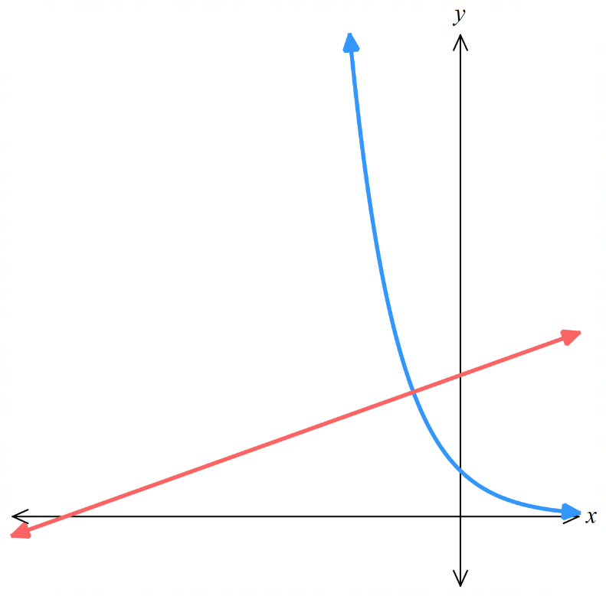
$$a)\frac{dy}{dx}= -e^{-x}, at P\left(-1, e\right): gradient = -e^{1}= -e$$

$$b) \frac{1}{e}$$

$$c) y - e = \left(\frac{1}{e}\right)\left(x + 1\right),$$
$$so y = \left(\frac{1}{e}\right)x +\frac{1}{e}+ e$$

$$d) x intercept: 0 = \left(\frac{1}{e}\right)x +\frac{1}{e}+ e, so x = -1 - e^{2}$$
$$y intercept: y =\frac{1}{e}+ e$$

$$e) Area = \left(\frac{1}{2}\right)× \left|1 + e^{2}\right|× \left|\frac{1}{e}+ e\right|=\left(\frac{1}{2}\right)\left(1 + e^{2}\right)\frac{\left(1 + e^{2}\right)}{e}=\frac{{\left(1 + e^{2}\right)}^{2}}{2e}$$

  - Use the derivative to find the gradient of the tangent to $y = e^{x}$ at $B(0, 1)$.
  - Hence find the equation of this tangent and show that it meets the $x$-axis at $F(-1, 0)$.
  - Use the derivative to find the gradient of the tangent to $y = e^{-x}$ at $B(0, 1)$.
  - Hence find the equation of this tangent and show that it meets the $x$-axis at $G(1, 0).$
  - Sketch $y = e^{x}$ and $y = e^{-x}$ on the same set of axes, showing the two tangents.
  - What sort of triangle is $△BFG$, and what is its area?
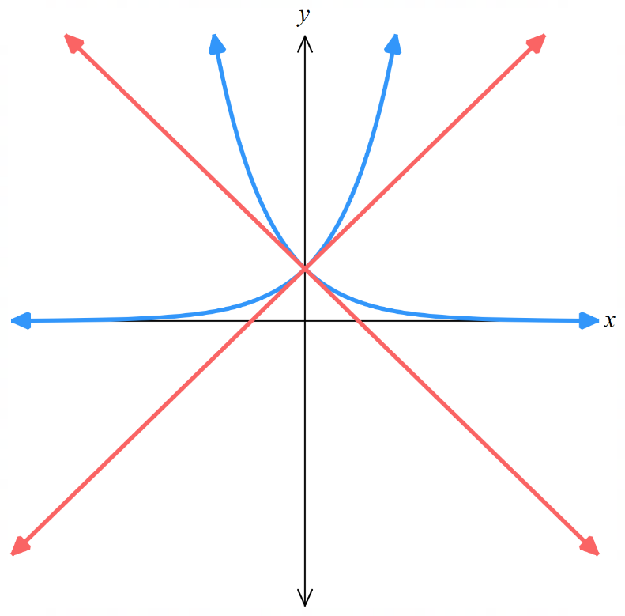
$$a)\frac{dy}{dx}= e^{x}, at B\left(0, 1\right): gradient = 1$$

$$b) y - 1 = 1\left(x - 0\right),$$
$$y = x + 1$$
$$At x axis: 0 = x + 1, so x = -1, ∴F\left(-1, 0\right)$$

$$c)\frac{dy}{dx}= -e^{-x}, at B\left(0, 1\right): gradient = -1$$

$$d) y - 1 = -1\left(x - 0\right)$$
$$y = -x + 1$$
$$At x axis: 0 = -x + 1,$$
$$x = 1, ∴ G\left(1, 0\right)$$

$$f) △BFG is isosceles right triangle with area = \left(\frac{1}{2}\right)× 2 × 1 = 1$$

  - Show that the equation of the tangent to $y = 1 - e^{-x}$ at the origin is $y = x$.
  - Deduce the equation of the normal at the origin without further use of calculus.
  - What is the equation of the asymptote of this curve?
  - Sketch the curve, showing the points $T$ and $N$ where the tangent and normal respectively cut the asymptote.
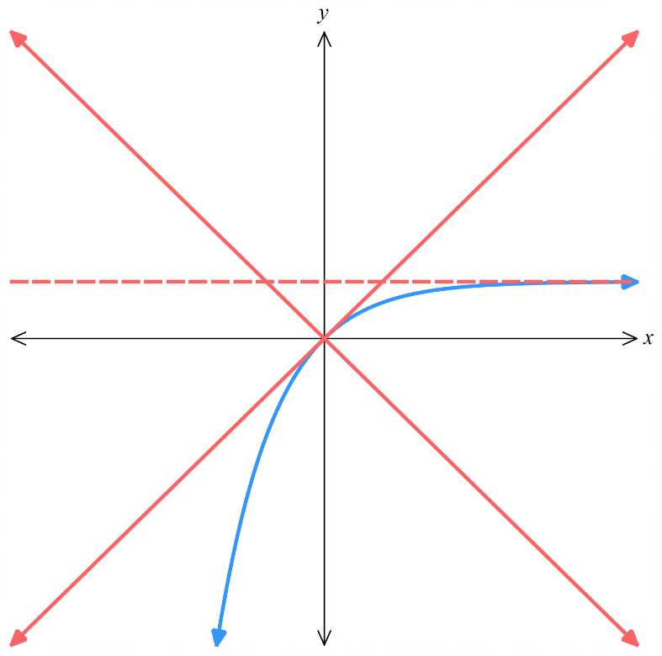
  - Find the area of $△OTN$.
$$a) At \left(0, 0\right):\frac{dy}{dx}= e^{-x}, gradient = e^{0}= 1$$
$$Tangent: y - 0 = 1\left(x - 0\right)$$
$$y = x$$
$$b) Normal gradient = -1, so normal: y = -x$$

$$c) Asymptote: y = 1$$

$$d) T where y = x meets y = 1:$$
$$x = 1, so T(1, 1)$$
$$N where y = -x meets y = 1:$$
$$-x = 1, so N(-1, 1)$$

$$e) Area of △OTN = \left(\frac{1}{2}\right)× 2 × 1 = 1$$

Chain Rule with Exponential Functions

- Review
- Differentiate exponential functions base $e$.
- $f\left(x\right)=e^{x}$ | - $f\left(x\right)=e^{2x}$ | - $f\left(x\right)=e^{3x-4}$
- $f\left(x\right)=e^{11-7x}$ | - $f\left(x\right)=e^{\left(\ln{5}\right)x}$ | - $f\left(x\right)=e^{7}$

- Investigation Chain rule for exponential functions.
Consider $y=e^{f\left(x\right)}$.
Using chain rule, find the general form of the derivative.
$$\frac{dy}{dx}=\frac{dy}{du}×\frac{du}{dx}$$
Let $u=f\left(x\right)$
$$\frac{du}{dx}=$$

Let $y=e^{u}$
$$\frac{dy}{du}=$$

- Chain Rule for Exponential Functions
$$y=e^{f\left(x\right)} \\ \frac{dy}{dx}= f^{'}\left(x\right) e^{f\left(x\right)}$$

- Identify the derivative of an exponential function.
$$f\left(x\right)=e^{3x+5}$$  $$f^{'}\left(x\right)=3e^{3x+5}$$ | $$f\left(x\right)=e^{x^{2}}$$  $$f^{'}\left(x\right)=2x e^{x^{2}}$$ | $$f\left(x\right)=e^{7x^{3}+{5x}^{2}+3}$$  $$f^{'}\left(x\right)=\left(21x^{2}+10x\right) e^{7x^{3}+{5x}^{2}+3}$$
Differentiate these functions.
- $f\left(x\right)=e^{2x+5}$ | - $f\left(x\right)=e^{-4x^{2}}$ | - $f\left(x\right)=e^{10x^{2}-11x}$
- $f\left(x\right)=e^{x^{2}-2}$ | - $f\left(x\right)=e^{15x^{3}-3x}$ | - $f\left(x\right)=e^{\frac{1}{x^{2}}}$

- Example Differentiate exponential functions base $e$.
Differentiate  $y={\left(e^{2x}-3\right)}^{4}$ use chain rule  $$y'=4{\left(e^{2x}-3\right)}^{3}×\left(2e^{2x}\right)$$  $$=8e^{2x}{\left(e^{2x}-3\right)}^{3}$$ | Differentiate  $y=x^{3}e^{1-x^{2}}$ use product rule  $$y'=u^{'}v+uv^{'}$$  $$=3x^{2}\left(e^{1-x^{2}}\right)+x^{3}\left(-2xe^{1-x^{2}}\right)$$  $$=3x^{2}\left(e^{1-x^{2}}\right)-2x^{4}\left(e^{1-x^{2}}\right)$$  $$=x^{2}\left(e^{1-x^{2}}\right)\left(3-2x^{2}\right)$$

- Practice
Differentiate  $$y=x^{3}e^{5x^{2}}$$  $$x^{2}e^{5x^{2}}\left(10x^{2}+3\right)$$ | Differentiate  $$y={\left(e^{x}+2x\right)}^{3}$$  $$3\left(e^{x}+2\right){\left(e^{x}+2x\right)}^{2}$$
Differentiate  $$y=\frac{e^{2x+3}}{1-x}$$  $$\frac{e^{2x+3}\left(3-2x\right)}{{\left(1-x\right)}^{2}}$$ | Differentiate  $$y=e^{3-x^{2}}\left(1-x\right)$$  $$e^{3-x^{2}}\left(2x^{2}-2x-1\right)$$

Foundation
- Use the chain rule to differentiate:
- $y = e^{ax+b}$  $$\frac{dy}{dx}= ae^{ax+b}$$ | - $y = e^{x^{2}}$  $$\frac{dy}{dx}= 2xe^{x^{2}}$$ | - $y = e^{-\frac{x^{2}}{2}}$  $$\frac{dy}{dx}= -xe^{-\left(\frac{1}{2}\right)x^{2}}$$
- $y = e^{x^{2}+1}$  $$\frac{dy}{dx}= 2xe^{x^{2}+1}$$ | - $y = e^{1-x^{2}}$  $$\frac{dy}{dx}= -2xe^{1-x^{2}}$$ | - $y = e^{x^{2}+2x}$  $$\frac{dy}{dx}= 2\left(x + 1\right)e^{x^{2}+2x}$$
- $y = e^{6+x-x^{2}}$  $$\frac{dy}{dx}= \left(1 - 2x\right)e^{6+x-x^{2}}$$ | - $y =\frac{e^{3x^{2}-2x+1}}{2}$  $$\frac{dy}{dx}= \left(\frac{1}{2}\right)\left(6x - 2\right)e^{3x^{2}-2x+1}$$  $$= \left(3x - 1\right)e^{3x^{2}-2x+1}$$

- Use the product rule to differentiate:
- $y = xe^{x}$  $$y^{'}= e^{x}+ xe^{x}= \left(x + 1\right)e^{x}$$ | - $y = xe^{-x}$  $$y^{'}= e^{-x}- xe^{-x}$$  $$= \left(1 - x\right)e^{-x}$$ | - $y = \left(x - 1\right)e^{x}$  $$y^{'}= e^{x}+ \left(x - 1\right)e^{x}$$  $$= xe^{x}$$
- $y = \left(x + 1\right)e^{3x-4}$  $$y^{'}= e^{3x-4}+ 3\left(x + 1\right)e^{3x-4}$$  $$= \left(3x + 4\right)e^{3x-4}$$ | - $y = x^{2}e^{-x}$  $$y^{'}= 2xe^{-x}- x^{2}e^{-x}$$  $$= \left(2x - x^{2}\right)e^{-x}$$ | - $y = \left(2x - 1\right)e^{2x}$  $$y^{'}= 2e^{2x}+ 2\left(2x - 1\right)e^{2x}$$  $$= 4xe^{2x}$$
- $y = \left(x^{2}- 5\right)e^{x}$  $$y^{'}= 2xe^{x}+ \left(x^{2}- 5\right)e^{x}$$  $$= \left(x^{2}+ 2x - 5\right)e^{x}$$ | - $y = x^{3}e^{2x}$  $$y^{'}= 3x^{2}e^{2x}+ 2x^{3}e^{2x}$$  $$= x^{2}e^{2x}\left(3 + 2x\right)$$

- Use the quotient rule to differentiate:
- $y =\frac{e^{x}}{x}$  $$y^{'}=\frac{xe^{x}- e^{x}}{x^{2}}$$  $$= e^{x}\left(\frac{x - 1}{x^{2}}\right)$$ | - $y =\frac{x}{e^{x}}$  $$y^{'}=\frac{e^{x}- xe^{x}}{e^{2x}}$$  $$= \left(1 - x\right)e^{-x}$$ | - $y =\frac{e^{x}}{x^{2}}$  $$y^{'}=\frac{x^{2}e^{x}- 2xe^{x}}{x^{4}}$$  $$= \left(\frac{x - 2}{x^{3}}\right)e^{x}$$
- $y =\frac{x^{2}}{e^{x}}$  $$y^{'}=\frac{2xe^{x}- x^{2}e^{x}}{e^{2x}}$$  $$= \left(2x - x^{2}\right)e^{-x}$$ | - $y =\frac{e^{x}}{x + 1}$  $$y^{'}=\frac{\left(x + 1\right)e^{x}- e^{x}}{{\left(x + 1\right)}^{2}}$$  $$= \frac{xe^{x}}{{\left(x + 1\right)}^{2}}$$ | - $y =\frac{x + 1}{e^{x}}$  $$y^{'}=\frac{e^{x}- \left(x + 1\right)e^{x}}{e^{2x}}$$  $$= -xe^{-x}$$
- $y =\frac{x - 3}{e^{2x}}$  $$y^{'}=\frac{e^{2x}- 2\left(x - 3\right)e^{2x}}{e^{4x}}$$  $$= \left(7 - 2x\right)e^{-2x}$$ | - $y =\frac{1 - x^{2}}{e^{x}}$  $$y^{'}=\frac{-2xe^{x}- \left(1 - x^{2}\right)e^{x}}{e^{2x}}$$  $$= \left(x^{2}- 2x - 1\right)e^{-x}$$

- Expand and simplify each expression, then differentiate it.
- $\left(e^{x}+ 1\right)\left(e^{x}+ 2\right)$  $$y^{'}= 2e^{2x}+ 3e^{x}$$ | - $\left(e^{2x}+ 3\right)\left(e^{2x}- 2\right)$  $$y^{'}= 4e^{4x}+ 2e^{2x}$$ | - $\left(e^{-x}+ 2\right)\left(e^{-x}+ 4\right)$  $$y^{'}= -2e^{-2x}- 6e^{-x}$$
- $\left(e^{-3x}- 1\right)\left(e^{-3x}- 5\right)$  $$y^{'}= -6e^{-6x}+ 18e^{-3x}$$ | - $\left(e^{2x}+ 1\right)\left(e^{x}+ 1\right)$  $$y^{'}= 3e^{3x}+ 2e^{2x}+ e^{x}$$ | - $\left(e^{3x}- 1\right)\left(e^{-x}+ 4\right)$  $$y^{'}= 2e^{2x}+ 12e^{3x}+ e^{-x}$$  $$= 12e^{3x}+ 2e^{2x}+ e^{-x}$$

Development
- Use the chain rule to differentiate:
- $y = {\left(1 - e^{x}\right)}^{5}$  $$y' = -5e^{x}{\left(1 - e^{x}\right)}^{4}$$ | - $y = {\left(e^{4x}- 9\right)}^{4}$  $$y' = 16e^{4x}{\left(e^{4x}- 9\right)}^{3}$$
- $y =\frac{1}{e^{x}- 1}$  $$y' = -\frac{e^{x}}{{\left(e^{x}- 1\right)}^{2}}$$ | - $y =\frac{1}{{\left(e^{3x}+ 4\right)}^{2}}$  $$y' = -\frac{6e^{3x}}{{\left(e^{3x}+ 4\right)}^{3}}$$

  - Show by substitution that the function $y = 3e^{2x}$ satisfies the equation $\frac{dy}{dx}= 2y$.

$$y = 3e^{2x},$$
$$\frac{dy}{dx}= 6e^{2x}= 2\left(3e^{2x}\right)= 2y$$
  - Show by substitution that the function $y = 5e^{-4x}$ satisfies the equation $\frac{dy}{dx}= -4y$.

$$y = 5e^{-4x},$$
$$\frac{dy}{dx}= -20e^{-4x}= -4\left(5e^{-4x}\right)= -4y$$

- For the curve $y=e^{x^{2}}$ at $\left(1,e\right)$, find the equation of the tangent and normal in general form.

Tangent: $2ex-y-e=0$
Normal: $x+2ey-2e^{2}-1=0$

- Use the product, quotient and chain rules as appropriate to differentiate:
- $y = {\left(e^{x}+ 1\right)}^{3}$  $$y' = 3e^{x}{\left(e^{x}+ 1\right)}^{2}$$ | - $y = {\left(e^{x}+ e^{-x}\right)}^{4}$  $$y^{'}= 4\left(e^{x}- e^{-x}\right){\left(e^{x}+ e^{-x}\right)}^{3}$$
- $y = \left(1 + x^{2}\right)e^{1+x}$  $$y^{'}= 2\left(1 + x\right)e^{1+x}+ {\left(1 + x\right)}^{2}e^{1+x}$$  $$= {\left(1 + x\right)}^{2}e^{1+x}$$ | - $y = \left(x^{2}- x\right)e^{2x-1}$  $$y^{'}= 4xe^{2x-1}+ 2\left(2x^{2}- 1\right)e^{2x-1}$$  $$= \left(4x^{2}+ 4x - 2\right)e^{2x-1}$$  $$= 2\left(2x^{2}+ 2x - 1\right)e^{2x-1}$$  $$= \left(2x^{2}- 1\right)e^{2x-1}$$
- $y =\frac{e^{x}}{e^{x}+ 1}$  $$y^{'}=\frac{e^{x\left(e^{x}+ 1\right)}- e^{x\left(e^{x}\right)}}{{\left(e^{x}+ 1\right)}^{2}}$$  $$=\frac{e^{x}}{{\left(e^{x}+ 1\right)}^{2}}$$ | - $y =\frac{e^{x}+ 1}{e^{x}- 1}$  $$y^{'}=\frac{e^{x\left(e^{x}- 1\right)}- e^{x\left(e^{x}+ 1\right)}}{{\left(e^{x}- 1\right)}^{2}}$$  $$= -\frac{2e^{x}}{{\left(e^{x}- 1\right)}^{2}}$$

- Write each expression as the sum of simple powers of e, then differentiate it.
- $y =\frac{e^{x}+ 1}{e^{x}}$  $$y = 1 + e^{-x}$$  $$y' = -e^{-x}$$ | - $y =\frac{e^{2x}+ e^{x}}{e^{x}}$  $$y = e^{x}+ 1$$  $$y' = e^{x}$$
- $y =\frac{2 - e^{x}}{e^{2x}}$  $$y = 2e^{-2x}- e^{-x}$$  $$y^{'}= -4e^{-2x}+ e^{-x}$$  $$= e^{-x} - 4e^{-2x}$$ | - $y =\frac{3 + e^{x}}{e^{4x}}$  $$y = 3e^{-4x}+ e^{-3x}$$  $$y^{'}= -12e^{-4x}- 3e^{-3x}$$
- $y =\frac{e^{x}+ e^{2x}- 3e^{4x}}{e^{x}}$  $$y = 1 + e^{x}- 3e^{3x}$$  $$y^{'}= e^{x}- 9e^{3x}$$ | - $y =\frac{e^{2x}+ 2e^{x}+ 1}{e^{2x}}$  $$y = 1 + 2e^{-x}+ e^{-2x}$$  $$y^{'}= -2e^{-x}- 2e^{-2x}$$
- Differentiate these functions.
- $y = \sqrt{e^{x}}$  $$y = e^{\frac{x}{2}}$$  $$y^{'}=\frac{e^{\frac{x}{2}}}{2}$$  $$=\frac{\sqrt{e^{x}}}{2}$$ | - $y = \sqrt[3]{e^{x}}$  $$y = e^{\frac{x}{3}}$$  $$y^{'}=\frac{e^{\frac{x}{3}}}{3}$$  $$=\frac{\sqrt[3]{e^{x}}}{3}$$ | - $y =\frac{1}{\sqrt{e^{x}}}$  $$y = e^{-\frac{x}{2}}$$  $$y^{'}= -\frac{e^{-\frac{x}{2}}}{2}$$  $$= -\frac{1}{2\sqrt{e^{x}}}$$
- $y =\frac{1}{\sqrt[3]{e^{x}}}$  $$y = e^{-\frac{x}{3}}$$  $$y' = -\frac{e^{-\frac{x}{3}}}{3}$$  $$= -\frac{1}{3\sqrt[3]{e^{x}}}$$ | - $e^{\sqrt{x}}$  $$y^{'}=\frac{e^{\sqrt{x}}}{2\sqrt{x}}$$ | - $e^{-\sqrt{x}}$  $$y^{'}= -\frac{e^{-\sqrt{x}}}{2\sqrt{x}}$$
- $e^{\frac{1}{x}}$  $$y^{'}= -\frac{e^{\frac{1}{x}}}{x^{2}}$$ | - $e^{-\frac{1}{x}}$  $$y^{'}=\frac{e^{-\frac{1}{x}}}{x^{2}}$$ | $$.$$

- An object moves according to $x=$ $\frac{e^{t-0.1t^{3}}}{2}$
  - find its displacement and velocity $t=2$ seconds.

Displacement at t = 2:
x(2) ≈ 1.66 m

Velocity:
$$\frac{dx}{dt}=\frac{\left(1 - 0.3t^{2}\right)\left(e^{t-0.1t^{3}}\right)}{2}$$
$$v\left(2\right)≈ -0.332 m/s$$

  - what is its displacement and velocity as $t→∞$?

Displacement and velocity both approach 0.

Derivative of Exponential Functions of Any Base

- Review
- Differentiate exponential functions base $e$.
- $f\left(x\right)=e^{\left(\ln{5}\right)x}$ | - $f\left(x\right)=e^{\left(\log_{3}{7}\right)x}$ | - $f\left(x\right)=e^{\left(\log_{5}{{13}^{x}}\right)}$

- Change the base of an exponential using $e^{\log_{e}{a}}=a$.
- $e^{\log_{e}{7}}=$ | - $e^{\ln{5}}=$ | - $12=e^{\left( \right)}$
- ${12}^{x}=e^{( )}$ | - $7^{x}=$ | - $7^{-x}$

- Investigation Derivative of exponential functions of any base.
We know that $\frac{d\left(e^{ax+b}\right)}{dx}$ $=ae^{ax+b}$; our rule currently only works for base $e$.
Consider $f\left(x\right)=2^{x}$, to find the derivative of this function, we can express $2^{x}$ with base $e$ by using the identity $e^{\log_{e}{a}}=a$:

$$f\left(x\right)=2^{x}=e^{\left(\log_{e}{2^{x}}\right)} \\ =e^{x\log_{e}{2}}$$

$f^{'}\left(x\right)=\left(\log_{e}{2}\right)e^{x\log_{e}{2}}$
$=\left(\ln{2}\right)⋅2^{x}$

Follow the steps above to differentiate:
$$f\left(x\right)={10}^{x}$$

$f^{'}\left(x\right)=$

- Derivative of Exponential Functions of Any Base
Every positive real number can be written with base $e$: $a=e^{\ln{a}}$
Every exponential function can be written with base $e$: $a^{x}=e^{x\ln{a}}$
To differentiate exponential functions of any base:

$$f\left(x\right)=a^{x} \\ f^{'}\left(x\right)=\left(\ln{a}\right) a^{x}$$

- Identify the derivative of an exponential function.
$$f\left(x\right)={11}^{x}$$  $$f^{'}\left(x\right)=\left(\ln{11}\right) {11}^{x}$$ | $$f\left(x\right)={13}^{x}$$  $$f^{'}\left(x\right)=\left(\ln{13}\right) {13}^{x}$$ | $$f\left(x\right)=3^{x}$$  $$f^{'}\left(x\right)=\left(\ln{3}\right) 3^{x}$$
Differentiate these functions.
- $f\left(x\right)={17}^{x}$ | - $f\left(x\right)={25}^{x}$ | - $f\left(x\right)={716}^{x}$
- $f\left(x\right)=5×5^{x}$ | - $f\left(x\right)=5^{x+1}$ | - $f\left(x\right)={\left(-3\right)}^{x}$

- Investigation Chain rule for exponential functions of any base.
Consider $y=a^{f\left(x\right)}$.
Using chain rule, find the general form of the derivative.
$$y=a^{f\left(x\right)}$$
$$\frac{dy}{dx}=\frac{dy}{du}×\frac{du}{dx}$$
Let $u=f\left(x\right)$
$$\frac{du}{dx}=$$

Let $y=a^{u}$
$$\frac{dy}{du}=$$

- Chain Rule for Exponential Functions of Any Base
$$y=a^{f\left(x\right)} \\ \frac{dy}{dx}= f^{'}\left(x\right) \left(\ln{a}\right) a^{f\left(x\right)}$$

- Identify the derivative of an exponential function.
$$f\left(x\right)={11}^{13x+5}$$  $$f^{'}\left(x\right)=13\left(\ln{11}\right){11}^{13x+5}$$ | $$f\left(x\right)={13}^{x^{2}}$$  $$f^{'}\left(x\right)=2x \left(\ln{13}\right) {13}^{x^{x}}$$ | $$f\left(x\right)=5^{x^{3}-7x+3}$$  $$f^{'}\left(x\right)=\left(3x^{2}-7\right)\left(\ln{5}\right)5^{x^{3}-7x+3}$$
Differentiate these functions.
- $f\left(x\right)=3^{2x+5}$ | - $f\left(x\right)=7^{-4x}$ | - $f\left(x\right)=8^{x-11}$
- $f\left(x\right)=7^{x^{2}}$ | - $f\left(x\right)={12}^{5x^{2}+11}$ | - $f\left(x\right)={19}^{3x^{5}-12x}$

Foundation
- Express these functions as powers of $e$, then differentiate them.
- $y=3ˣ$  $$y = 3ˣ = eˣ ˡⁿ ³$$  $$\frac{dy}{dx}= 3ˣ ln 3$$ | - $y = 4ˣ$  $$y = 4ˣ = eˣ ˡⁿ ⁴$$  $$\frac{dy}{dx}= 4ˣ ln 4$$ | - $y = 2ˣ$  $$y = 2ˣ = eˣ ˡⁿ ²$$  $$\frac{dy}{dx}= 2ˣ ln 2$$

- Differentiate using the formula.
- $y = 10ˣ$  $$\frac{dy}{dx}= 10ˣ ln 10$$ | - $y = 8ˣ$  $$\frac{dy}{dx}= 8ˣ ln 8$$ | - $y = 3 × 5ˣ$  $$\frac{dy}{dx}= 3\left(ln 5\right)\left(5ˣ\right)$$

- Differentiate $y=2^{3x-4}$.

$$\frac{dy}{dx}=3\left(2^{3x-4}\right)\ln{2}$$
- Find the equation of the tangent to the curve $y = 4^{x+1}$ when $x=0$. Answer in general form.

At $x=0, y=4$
$$\frac{dy}{dx}= 4^{x+1} ln 4$$
$$At (0, 4): m = 4 ln 4$$
$$y - y₁ = m(x - x₁):$$
$$y - 4 = 4 ln 4(x - 0)$$
$$y = 4x ln 4 + 4$$
$$4x ln 4 - y + 4 = 0$$

